Name(s):
_______________________________________________________________________

Measuring Ocean Color – Data Table 1

Record LED value in the table below.
Sample | Blue LED value | Green LED value | Red LED value
Clear water
Blue water
Green water
Tea water

Measuring Ocean Color - Data Table 2

For each colored water sample, divide the values for red, green, and blue light by the value for the clear water sample and multiply by 100 for the percent of total light transmitted (i.e., clear water is 100% for each LED, percent of blue light transmitted through blue water is the blue LED value in blue water divided by the blue LED value in clear water: 73/97 = 75% in this example).

Calculate the percent of light transmitted in the table below.
Sample | Blue % transmitted | Green % transmitted | Red % transmitted
Clear water | 100 | 100 | 100
Blue water
Green water
Tea water

Measuring Ocean Color - Graph 1
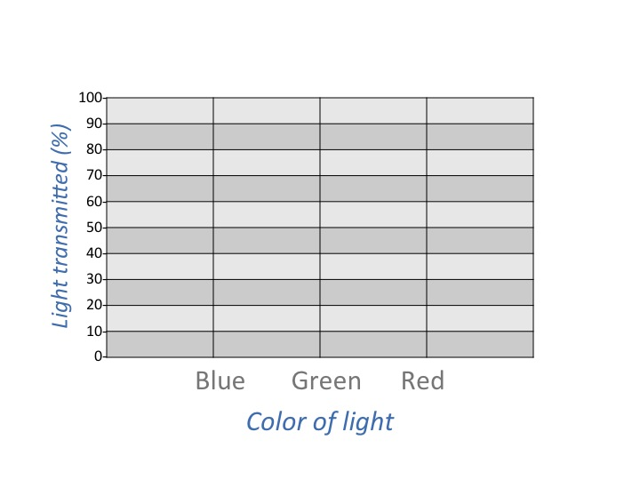

Measuring Ocean Color – Graph 2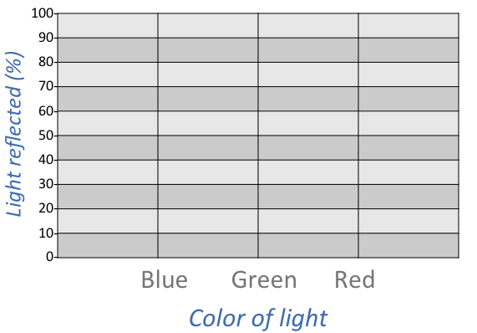
Name(s):
_______________________________________________________________________

Measuring Ocean Color – Data Table 3

Record LED value in the table below.
Sample | Blue LED value | Green LED value | Red LED value
+ 1 tsp milk
+1tsp milk + blue
+1tsp milk +green
+1tsp milk + tea

Measuring Ocean Color - Data Table 4

For each colored water sample, divide the values for red, green, and blue light by the value for the clear water sample and multiply by 100 for the percent of total light transmitted (i.e., clear water is 100% for each LED, percent of blue light transmitted through blue water is the blue LED value in blue water divided by the blue LED value in clear water: 73/97 = 75% in this example).

Calculate the percent of light transmitted in the table below
Sample | Blue % transmitted | Green % transmitted | Red % transmitted
+ 1 tsp milk | 100 | 100 | 100
+1tsp milk + blue
+1tsp milk +green
+1tsp milk + tea

